## User’s Guide

### How to create a Calendar Event

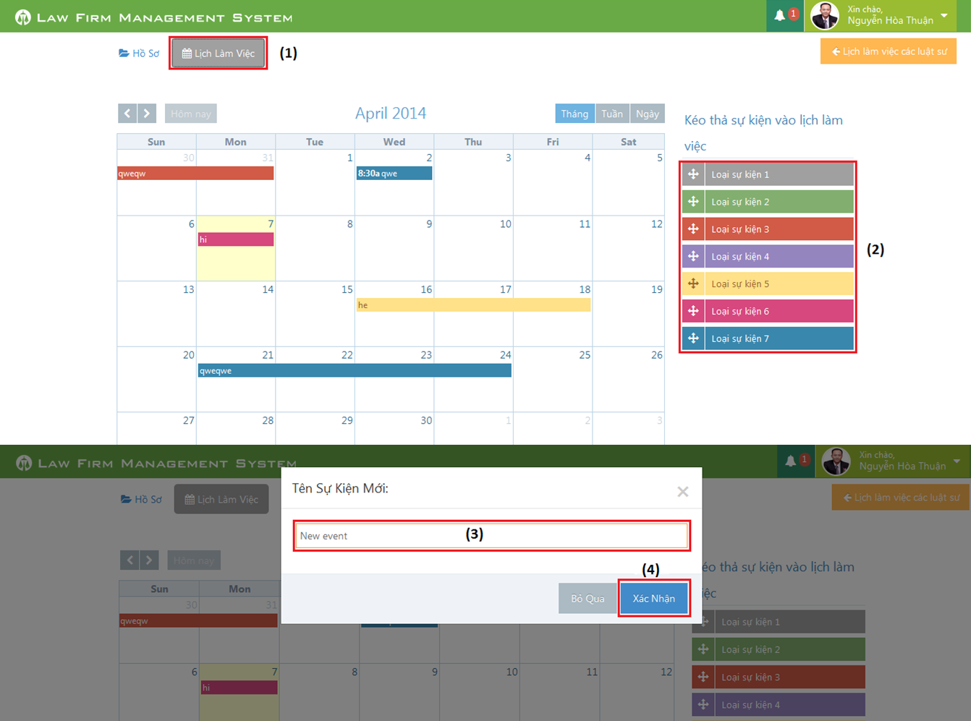

Figure 242: How to create a Calendar Event

|  |  |
| --- | --- |
| Step | Description |
| 1 | At Index page, click at “Lịch làm việc” tab |
| 2 | Drag any event and drop it into calendar.  (User can also click or click and drag anywhere in calendar to create a new event) |
| 3 | Input New calendar event name. |
| 4 | Press “Xác nhận” button to create new calendar event. |

### How to create an Operation Event

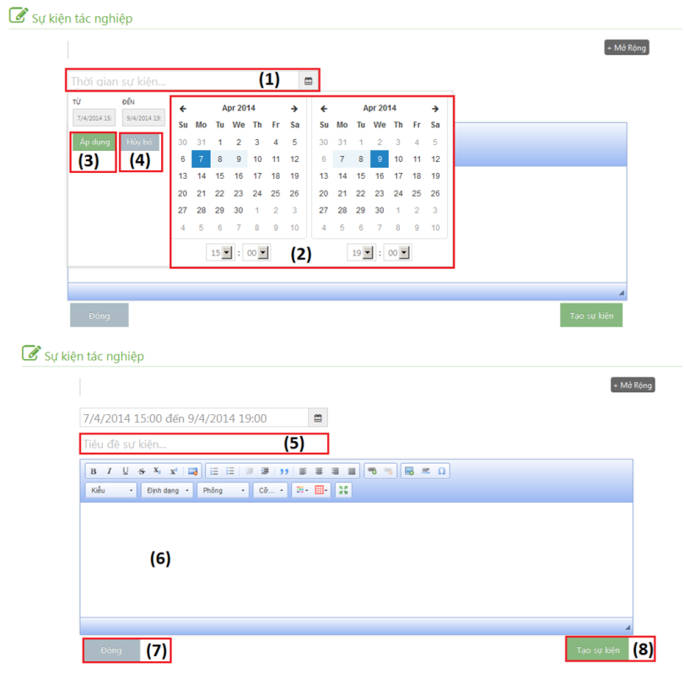

Figure 243: How to create an Operation Event

|  |  |
| --- | --- |
| Step | Description |
| 1 | Click to text box to add time start and finish of event |
| 2 | Choose date and time of event |
| 3 | Click [Áp dụng] button to input data on “Thời gian sự kiện” |
| 4 | Click [Hủy bỏ] button to cancel input |
| 5 | Input title of event |
| 6 | Input content of event include: text, image…. |
| 7 | Click [Đóng] button to close Popup and back to [List event] screen |
| 8 | Click [Tạo sự kiện] to insert new operation event |

### How to upload photos to Documents Related

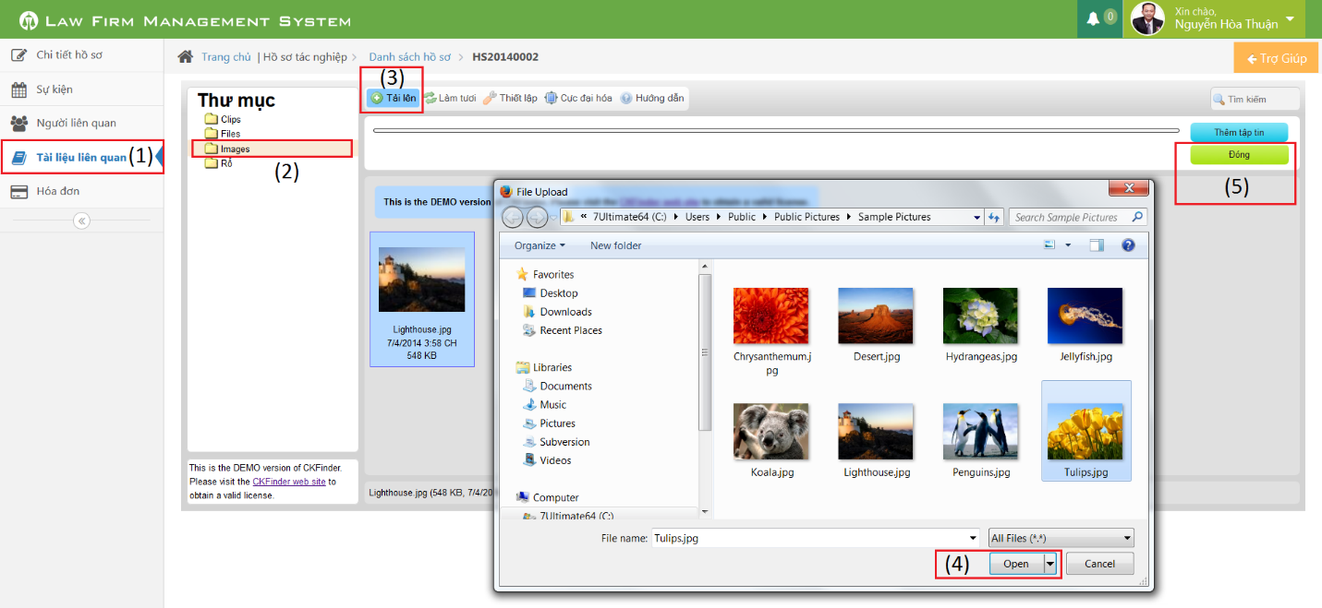

Figure 244: How to upload photos to Documents Related

|  |  |
| --- | --- |
| Step | Description |
| 1 | Go to case detail page and then click on “Tài liệu liên quan” link |
| 2 | Click on “Images” button (can upload only image file format) |
| 3 | Click on “Tải lên” button to show a popup |
| 4 | Choose one or many photos and then click “Open” button |
| 5 | Click on “Đóng” button to complete upload |

### How to search in Thư Viện Pháp Luật

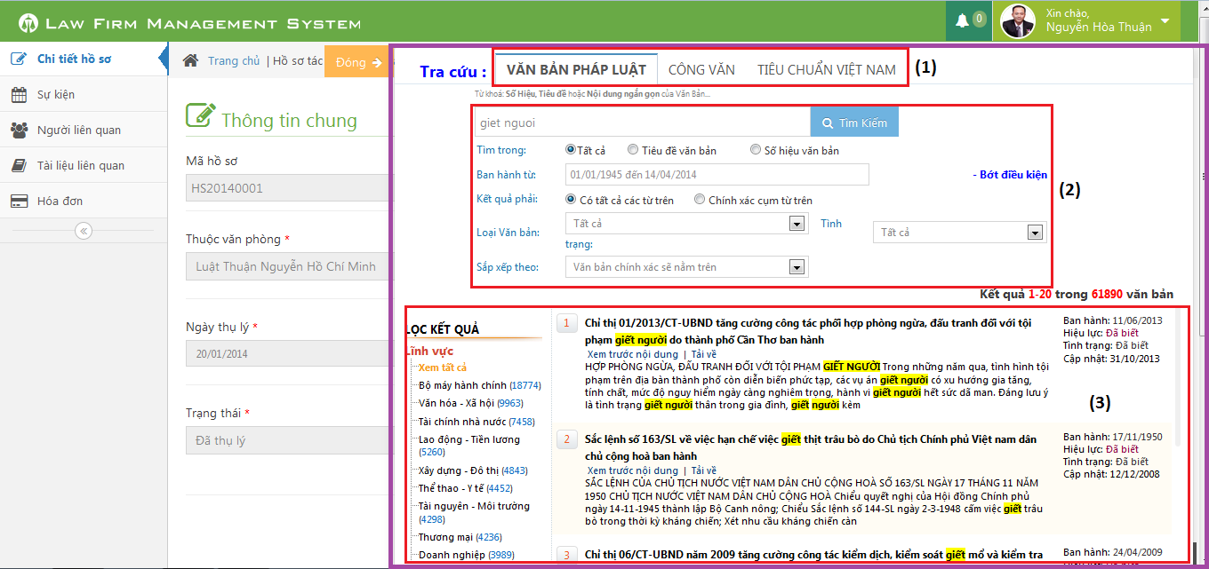

Figure 245: How to search in Thư Viện Pháp Luật

|  |  |
| --- | --- |
| Step | Description |
| 1 | Open “Trợ giúp” pop-up and choose the Document type that you want to search. |
| 2 | Input the conditional to search the document. |
| 3 | After press “Tìm kiếm” button, the result will be showed. |

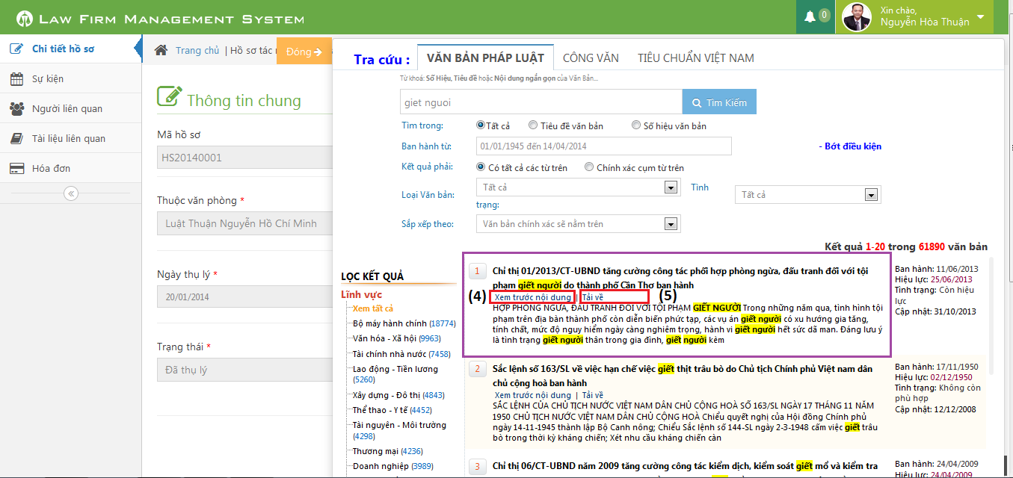

Figure 246: How to Preview or Download file

|  |  |
| --- | --- |
| Step | Description |
| 4 | Each result, user can pre-view by click at “Xem trước nội dung” link. |
| 5 | User can also download the document by click at “Tải về” link. |

### How to create a Staff

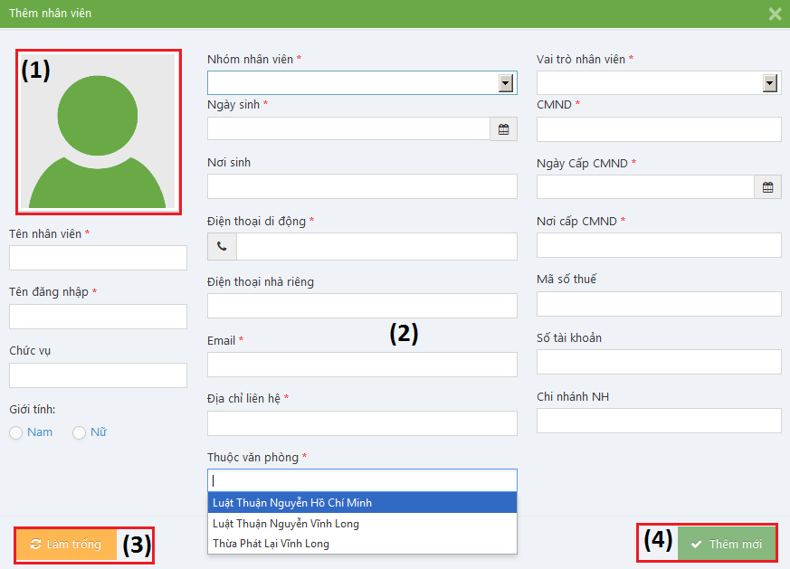

Figure 247: How to create a Staff

|  |  |
| --- | --- |
| Step | Description |
| 1 | Click to input avatar of staff |
| 2 | Fill information of staff:  - Tên nhân viên, Tên đăng nhập, Nhóm nhân viên, Ngày sinh, Điện thoại di động, Email, Địa chỉ liên hệ, Thuộc văn phòng, Vai trò nhân viên, CMND, Ngày cấp CMND, Nơi cấp CMND is required  - Điện thoại di động, Điện thoại nhà riêng, CMND, Mã số thuế, Số tài khoản must be number  - Email to compliance with format |
| 3 | Click [Làm trống] button to clear all fill to blank. |
| 4 | Click [Thêm mới] button to insert new staff |

Figure 1: Waterfall Process Model 16

Figure 2: Roles and Responsibilities 17

Figure 3: Overview Use-Case Diagram 22

Figure 4: Login Use-Case Diagram 23

Figure 5: Logout Use-Case Diagram 25

Figure 6: Change Password Use-Case Diagram 26

Figure 7: View Home Use-Case Diagram 29

Figure 8: Notify Use-Case Diagram 30

Figure 9: Manage Calendar Event Use-Case Diagram 32

Figure 10: List Calendar Event Use-Case Diagram 33

Figure 11: Add New Calendar Event 34

Figure 12: Edit Calendar Event Use-Case Diagram 36

Figure 13: Delete Calendar Event Use-Case Diagram 38

Figure 14: Search Calendar Event Use-Case Diagram 40

Figure 15: Manage Case Use-Case Diagram 42

Figure 16: List All Cases Use-Case Diagram 42

Figure 17: Add New Case Use-Case Diagram 44

Figure 18: Search Case Use-Case Diagram 46

Figure 19: Manage Case Detail Use-Case Diagram 48

Figure 20: Manage Case Info Use-Case Diagram 49

Figure 21: View Case Info Use-Case Diagram 49

Figure 22: Edit Case Info Use-Case Diagram 51

Figure 23: Manage Operation Event Use-Case Diagram 54

Figure 24: List Operation Events Use-Case Diagram 54

Figure 25: View Operation Event Detail Use-Case Diagram 56

Figure 26: Add New Operation Event Use-Case Diagram 58

Figure 27: Edit Operation Event Use-Case Diagram 60

Figure 28: Delete Operation Event Use-Case Diagram 62

Figure 29: Manage Lawyer Related Use-Case Diagram 64

Figure 30: List Lawyers Related Use-Case Diagram 65

Figure 31: View Lawyer Related Detail Use-Case Diagram 66

Figure 32: Assign Lawyer Related Use-Case Diagram 68

Figure 33: Remove Lawyer Related Use-Case Diagram 70

Figure 34: Search Lawyer Related Use-Case Diagram 72

Figure 35: Manage Customer Related Use-Case Diagram 75

Figure 36: List Customers Related Use-Case Diagram 75

Figure 37: View Customer Related Detail Use-Case Diagram 77

Figure 38: Add Customer Related Use-Case Diagram 79

Figure 39: Remove Customer Related Use-Case Diagram 81

Figure 40: Search Customer Related Use-Case Diagram 83

Figure 41: Manage Subject Related Use-Case Diagram 85

Figure 42: List Subjects Related Use-Case Diagram 86

Figure 43: Add New Subject Related Use-Case Diagram 87

Figure 44: Edit Subject Related Use-Case Diagram 90

Figure 45: Delete Subject Related Use-Case Diagram 92

Figure 46: Manage Used Service Use-Case Diagram 94

Figure 47: List Used Services Use-Case Diagram 95

Figure 48: Add New Used Service Use-Case Diagram 96

Figure 49: Edit Used Service Use-Case Diagram 99

Figure 50: Delete Used Service Use-Case Diagram 101

Figure 51: Manage Payment Use-Case Diagram 104

Figure 52: List Payments Use-Case Diagram 104

Figure 53: Add New Payment Use-Case Diagram 106

Figure 54: Edit Payment Use-Case Diagram 108

Figure 55: Delete Payment Use-Case Diagram 111

Figure 56: Integrate Thư Viện Pháp Luật Use-Case Diagram 113

Figure 57: Search Document Use-Case Diagram 113

Figure 58: View Document Use-Case Diagram 115

Figure 59: Download Document Use-Case Diagram 117

Figure 60: Manage Customer Group Use-Case Diagram 119

Figure 61: List Customer Groups Use-Case Diagram 120

Figure 62: Add New Customer Group Use-Case Diagram 122

Figure 63: Edit Customer Group Use-Case Diagram 125

Figure 64: Delete Customer Group Use-Case Diagram 127

Figure 65: Search Customer Group Use-Case Diagram 130

Figure 66: Manage Customer Use-Case Diagram 132

Figure 67: List Customers Use-Case Diagram 133

Figure 68: View Customer Detail Use-Case Diagram 135

Figure 69: Add New Customer Use-Case Diagram 137

Figure 70: Edit Customer Use-Case Diagram 140

Figure 71: Delete Customer Use-Case Diagram 142

Figure 72: Search Customer Use-Case Diagram 145

Figure 73: Manage Staff Group Use-Case Diagram 147

Figure 74: List Staff Groups Use-Case Diagram 147

Figure 75: Add New Staff Group Use-Case Diagram 149

Figure 76: Edit Staff Group Use-Case Diagram 151

Figure 77: Delete Staff Group Use-Case Diagram 154

Figure 78: Search Staff Group Use-Case Diagram 156

Figure 79: Manage Staff Use-Case Diagram 158

Figure 80: List Staffs Use-Case Diagram 159

Figure 81: View Staff Detail Use-Case Diagram 160

Figure 82: Add New Staff Use-Case Diagram 163

Figure 83: Edit Staff Use-Case Diagram 166

Figure 84: Deactivate/Activate Staff Use-Case Diagram 169

Figure 85: Search Staff Use-Case Diagram 172

Figure 86: Reset Password Use-Case Diagram 173

Figure 87: Manage Service Type Use-Case Diagram 176

Figure 88: List Service Types Use-Case Diagram 177

Figure 89: Add New Service Type Use-Case Diagram 179

Figure 90: Edit Service Type Use-Case Diagram 182

Figure 91: Delete Service Type Use-Case Diagram 184

Figure 92: Search Service Type Use-Case Diagram 187

Figure 93: Manage Service Use-Case Diagram 189

Figure 94: List Services Use-Case Diagram 190

Figure 95: View Service Detail Use-Case Diagram 192

Figure 96: Add New Service Use-Case Diagram 194

Figure 97: Edit Service Use-Case Diagram 197

Figure 98: Delete Service Use-Case Diagram 199

Figure 99: Search Service Use-Case Diagram 201

Figure 100: Manage Office Use-Case Diagram 203

Figure 101: List Offices Use-Case Diagram 204

Figure 102: View Office Detail Use-Case Diagram 205

Figure 103: Add New Office Use-Case Diagram 207

Figure 104: Edit Office Use-Case Diagram 210

Figure 105: Deactivate/Activate Office Use-Case Diagram 213

Figure 106: Search Office Use-Case Diagram 215

Figure 107: Entity Relationship Diagram 218

Figure 108: System Architecture 220

Figure 109: MVC Architecture 220

Figure 110: Package Diagram 222

Figure 111: Data Transfer Class Diagram 223

Figure 112: Controller Class Diagram 224

Figure 113: Business Class Diagram 225

Figure 114: Data Access Class Diagram 225

Figure 115: Login Sequence Diagram 226

Figure 116: Change Password Sequence Diagram 227

Figure 117: View Home Sequence Diagram 228

Figure 118: Notify Sequence Diagram 229

Figure 119: List Calendar Events Sequence Diagram 229

Figure 120: Add New Calendar Event Sequence Diagram 230

Figure 121: Edit Calendar Event Sequence Diagram 230

Figure 122: Delete Calendar Event Sequence Diagram 231

Figure 123: List All Cases Sequence Diagram 231

Figure 124: Add New Case Sequence Diagram 232

Figure 125: List Operation Events Sequence Diagram 233

Figure 126: Add New Operation Event Sequence Diagram 234

Figure 127: Edit Operation Event Sequence Diagram 235

Figure 128: Delete Operation Event Sequence Diagram 236

Figure 129: Integrate Thư Viện Pháp Luật Sequence Diagram 237

Figure 130: List Customers Sequence Diagram 238

Figure 131: Add New Customer Sequence Diagram 238

Figure 132: Edit Customer Sequence Diagram 239

Figure 133: Delete Customer Sequence Diagram 239

Figure 134: List Staffs Sequence Diagram 240

Figure 135: Add New Staff Sequence Diagram 241

Figure 136: Edit Staff Sequence Diagram 242

Figure 137: Deactivate / Activate Staff Sequence Diagram 242

Figure 138: Reset Password Sequence Diagram 243

Figure 139: List Services Sequence Diagram 244

Figure 140: Add New Service Sequence Diagram 244

Figure 141: Edit Service Sequence Diagram 245

Figure 142: Delete Service Sequence Diagram 245

Figure 143: List Offices Sequence Diagram 246

Figure 144: Add New Office Sequence Diagram 246

Figure 145: Edit Office Sequence Diagram 247

Figure 146: Deactivate / Activate Office Sequence Diagram 247

Figure 147: Home Screen Image 248

Figure 148: Notify Event Screen Image 249

Figure 149: Dropdown Control Screen Image 250

Figure 150: Personal Calendar Screen Image 251

Figure 151: Shared Calendar Screen Image 252

Figure 152: All Cases Screen Image 253

Figure 153: Add New Case Screen Image 254

Figure 154: Case Info Screen Image 255

Figure 155: Operation Event Screen Image 256

Figure 156: Lawyer Related Screen Image 257

Figure 157: Customer Related Screen Image 258

Figure 158: Subject Related Screen Image 259

Figure 159: Document Related Screen Image 260

Figure 160: All Used Services / Payments Screen Image 261

Figure 161: Thư Viện Pháp Luật Screen Image 262

Figure 162: All Customers Screen Image 263

Figure 163: Customer Detail Screen Image 264

Figure 164: All Staffs Screen Image 266

Figure 165: Staff Detail Screen Image 267

Figure 166: All Services Screen Image 269

Figure 167: Service Detail Screen Image 270

Figure 168: All Offices Screen Image 271

Figure 169: Office Detail Screen Image 272

Figure 170: Relational Database Diagram 274

Figure 171 - Step 1: Archive website to Publish.zip 312

Figure 172 - Step 2: Upload Publish.zip to server 312

Figure 173 - Step 3: Upload database to server 313

Figure 174 - Step 4: Get information of database in server 313

Figure 175 - Step 5: Edit Web.config in server 314

Figure 176 - Step 6: Add domain name to host 314

Figure 177: How to create a Calendar Event 315

Figure 178: How to create an Operation Event 316

Figure 179: How to upload photos to Documents Related 317

Figure 180: How to search in Thư Viện Pháp Luật 318

Figure 181: How to Preview or Download file 318

Figure 182: How to create a Staff 319